Task 6.1C

Name of Student

Institutional Affiliation

**Question 1**

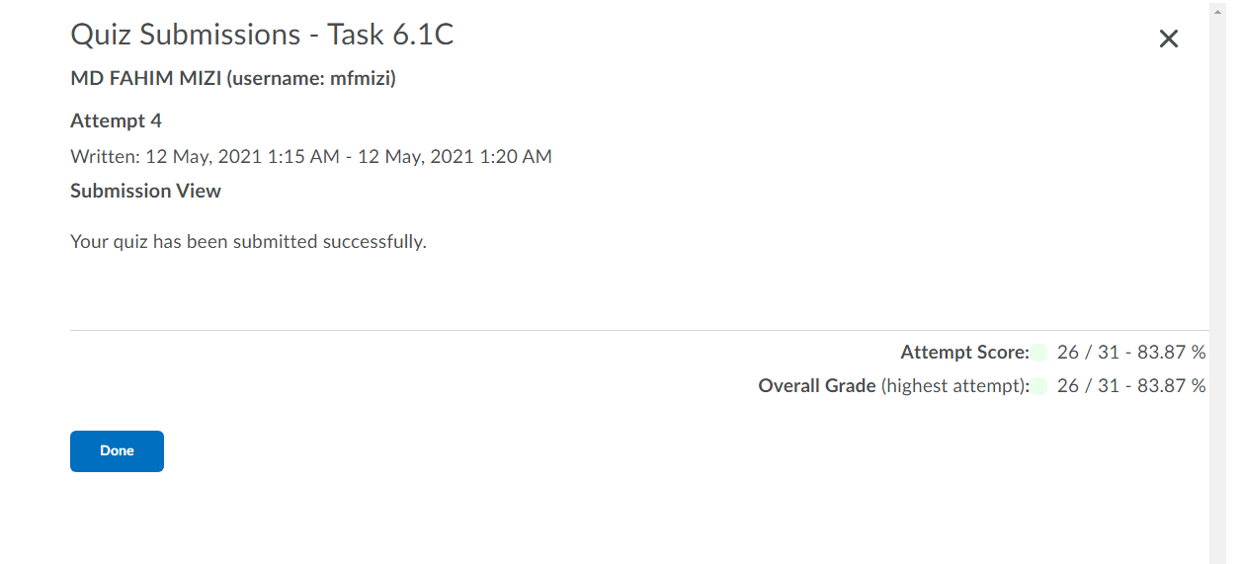

**Question 2: Reflection point**

The research process I have used has greatly increased in value compared to when I started the course. I have become well aware with resources that are helpful in performing certain tasks and how to handle the assignments. The textbook provided detailed information which helped greatly in answering the questions. The book also helped greatly in identifying the types of firewalls, the protocols used in each firewall, the differences, and identifying which layer they operate in the OSI model.